- Introduction
- Brief presentation of the designed model and its rules
The project's data model represents a pizzeria chain with the following key characteristics: each pizzeria has one owner (whose birthplace is recorded through city and country entities), maintains one or more unique menus with distinct plates, and operates through departments that are staffed by teams of employees organized by role.
- Conceptual diagram
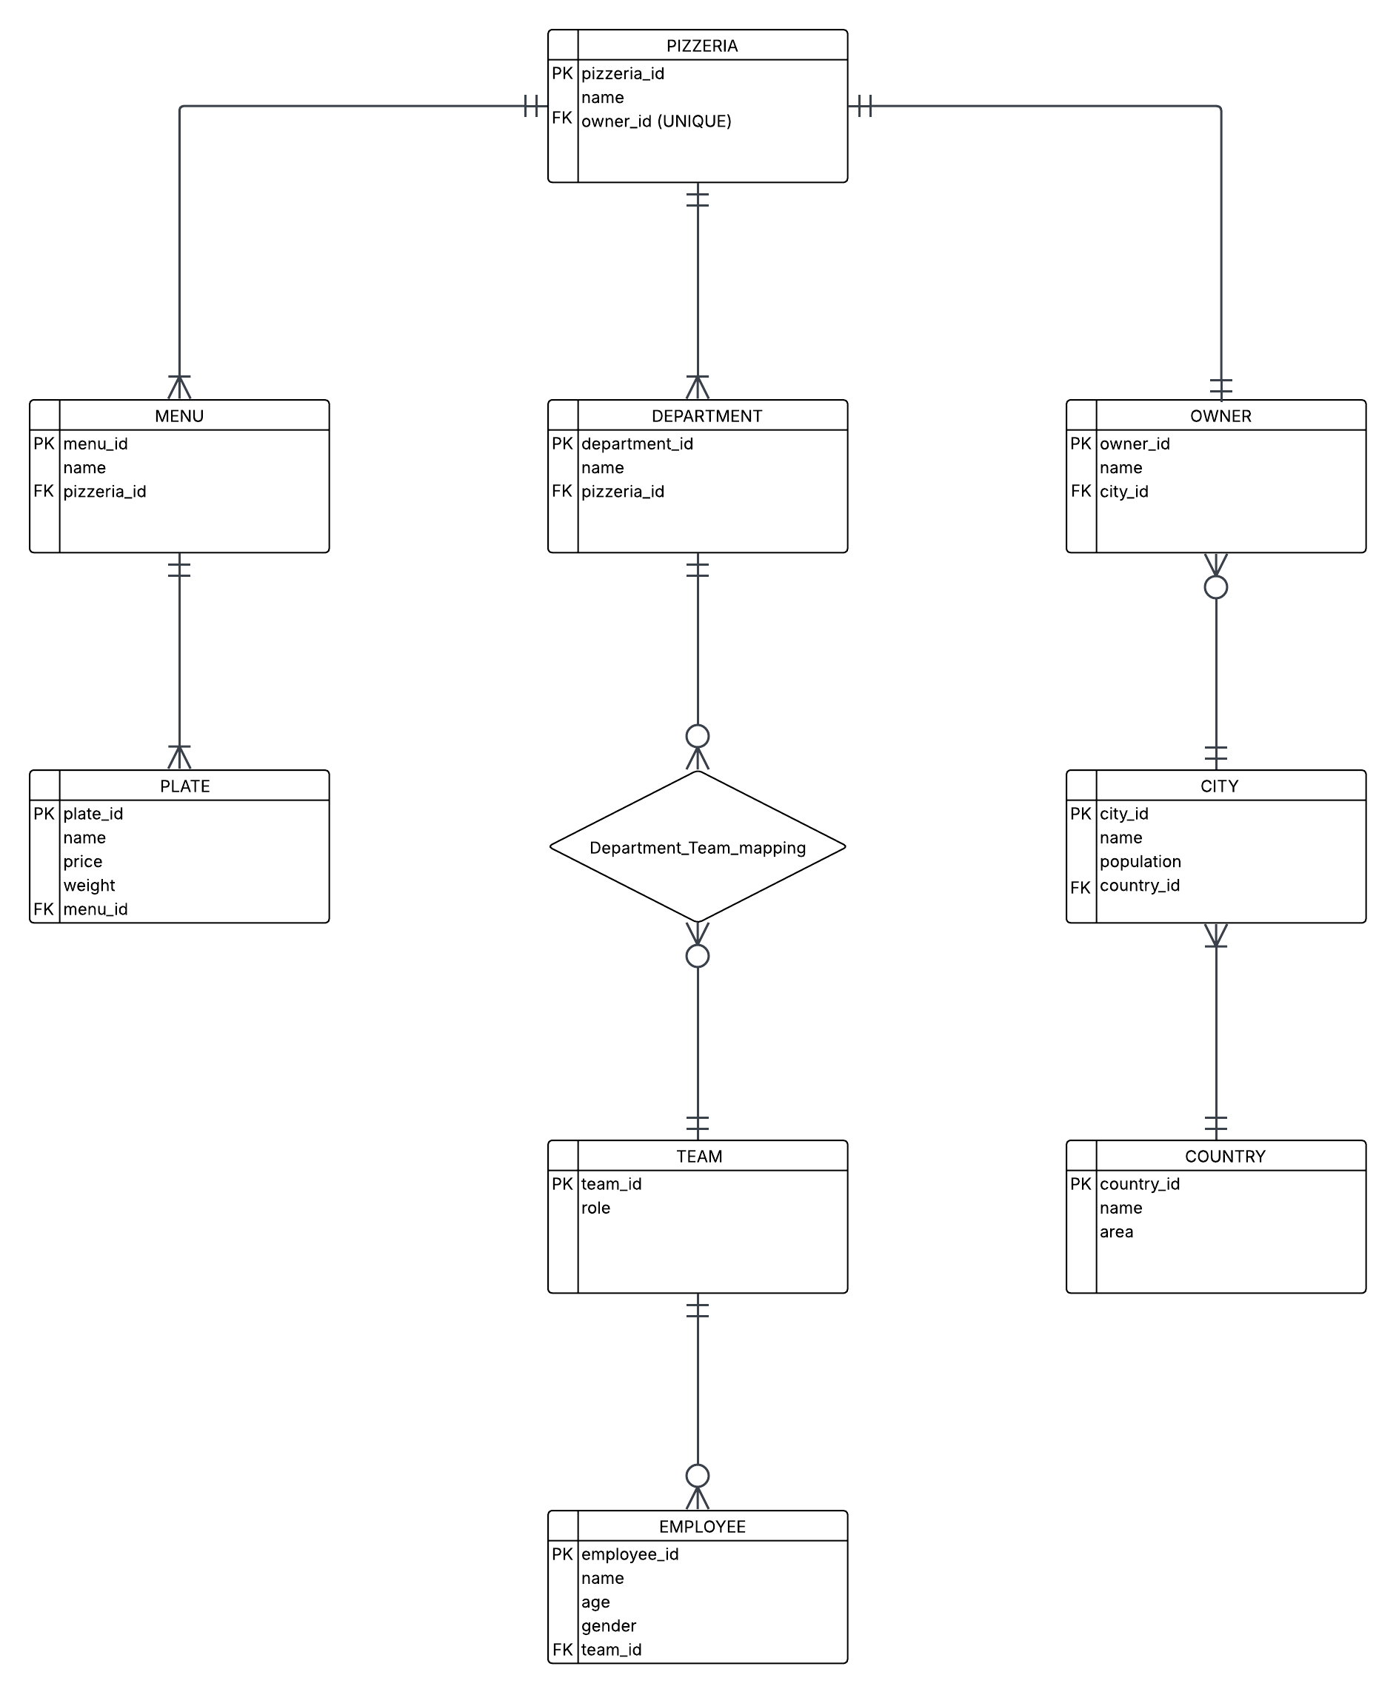
- Relational schemas
PIZZERIA (pizzeria_id: INT, name: VARCHAR(100), owner_id: INT)
PK: pizzeria_id
FK: owner_id REFERENCES OWNER (owner_id)
UNIQUE: owner_id
MENU (menu_id: INT, name: VARCHAR(100), pizzeria_id: INT)
PK: menu_id
FK: pizzeria_id REFERENCES PIZZERIA (pizzeria_id)
PLATE (plate_id: INT, name: VARCHAR(100), price: NUMBER(10,2), weight: INT, menu_id: INT)
PK: plate_id
FK: menu_id REFERENCES MENU (menu_id)
DEPARTMENT (department_id: INT, name: VARCHAR(100), pizzeria_id: INT)
PK: department_id
FK: pizzeria_id REFERENCES PIZZERIA (pizzeria_id)
DEPARTMENT_TEAM_MAPPING (department_id: INT, team_id: INT)
PK: (department_id, team_id)
FK: department_id REFERENCES DEPARTMENT (department_id)
FK: team_id REFERENCES TEAM (team_id)
TEAM (team_id: INT, role: VARCHAR(100))
PK: team_id
EMPLOYEE (employee_id: INT, name: VARCHAR(100), age: INT, gender: VARCHAR(1), team_id: INT)
PK: employee_id
FK: team_id REFERENCES TEAM (team_id)
OWNER (owner_id: INT, name: VARCHAR(100), city_id: INT)
PK: owner_id
FK: city_id REFERENCES CITY (city_id)
CITY (city_id: INT, name: VARCHAR(100), population: INT, country_id: INT)
PK: city_id
FK: country_id REFERENCES COUNTRY (country_id)
COUNTRY (country_id: INT, name: VARCHAR(100), area: INT)
PK: country_id
- Table creation (separate script)
Onutu_Radu-Constantin_510-create_insert.txt

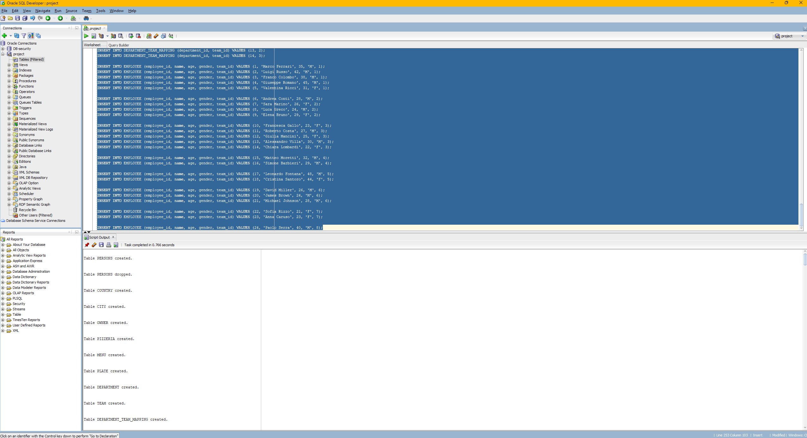

- Presentation of the security rules to be applied to the model
  - Data Encryption
- Data Encryption
Onutu_Radu-Constantin_510-encryption.txt
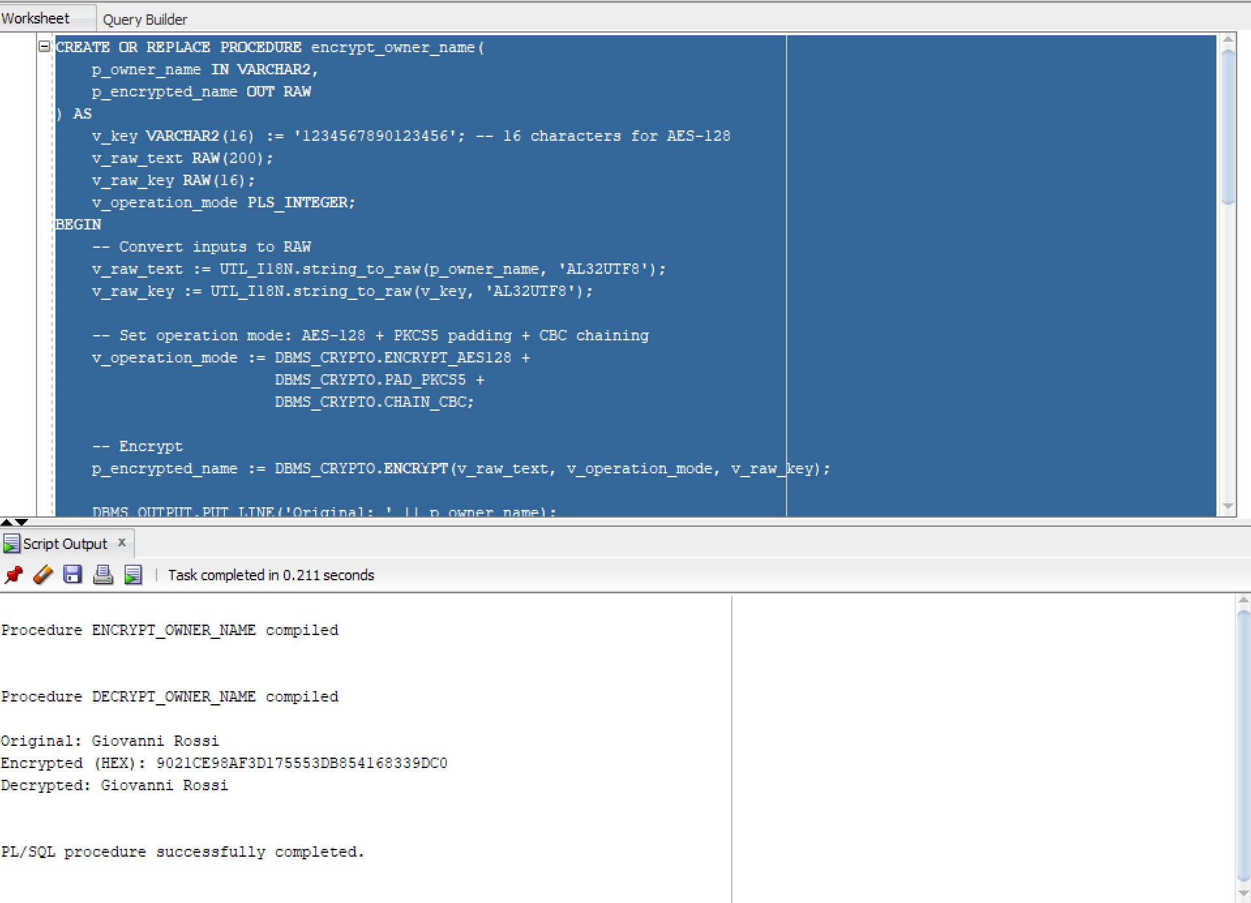
  - Simple Encryption/Decryption Procedures
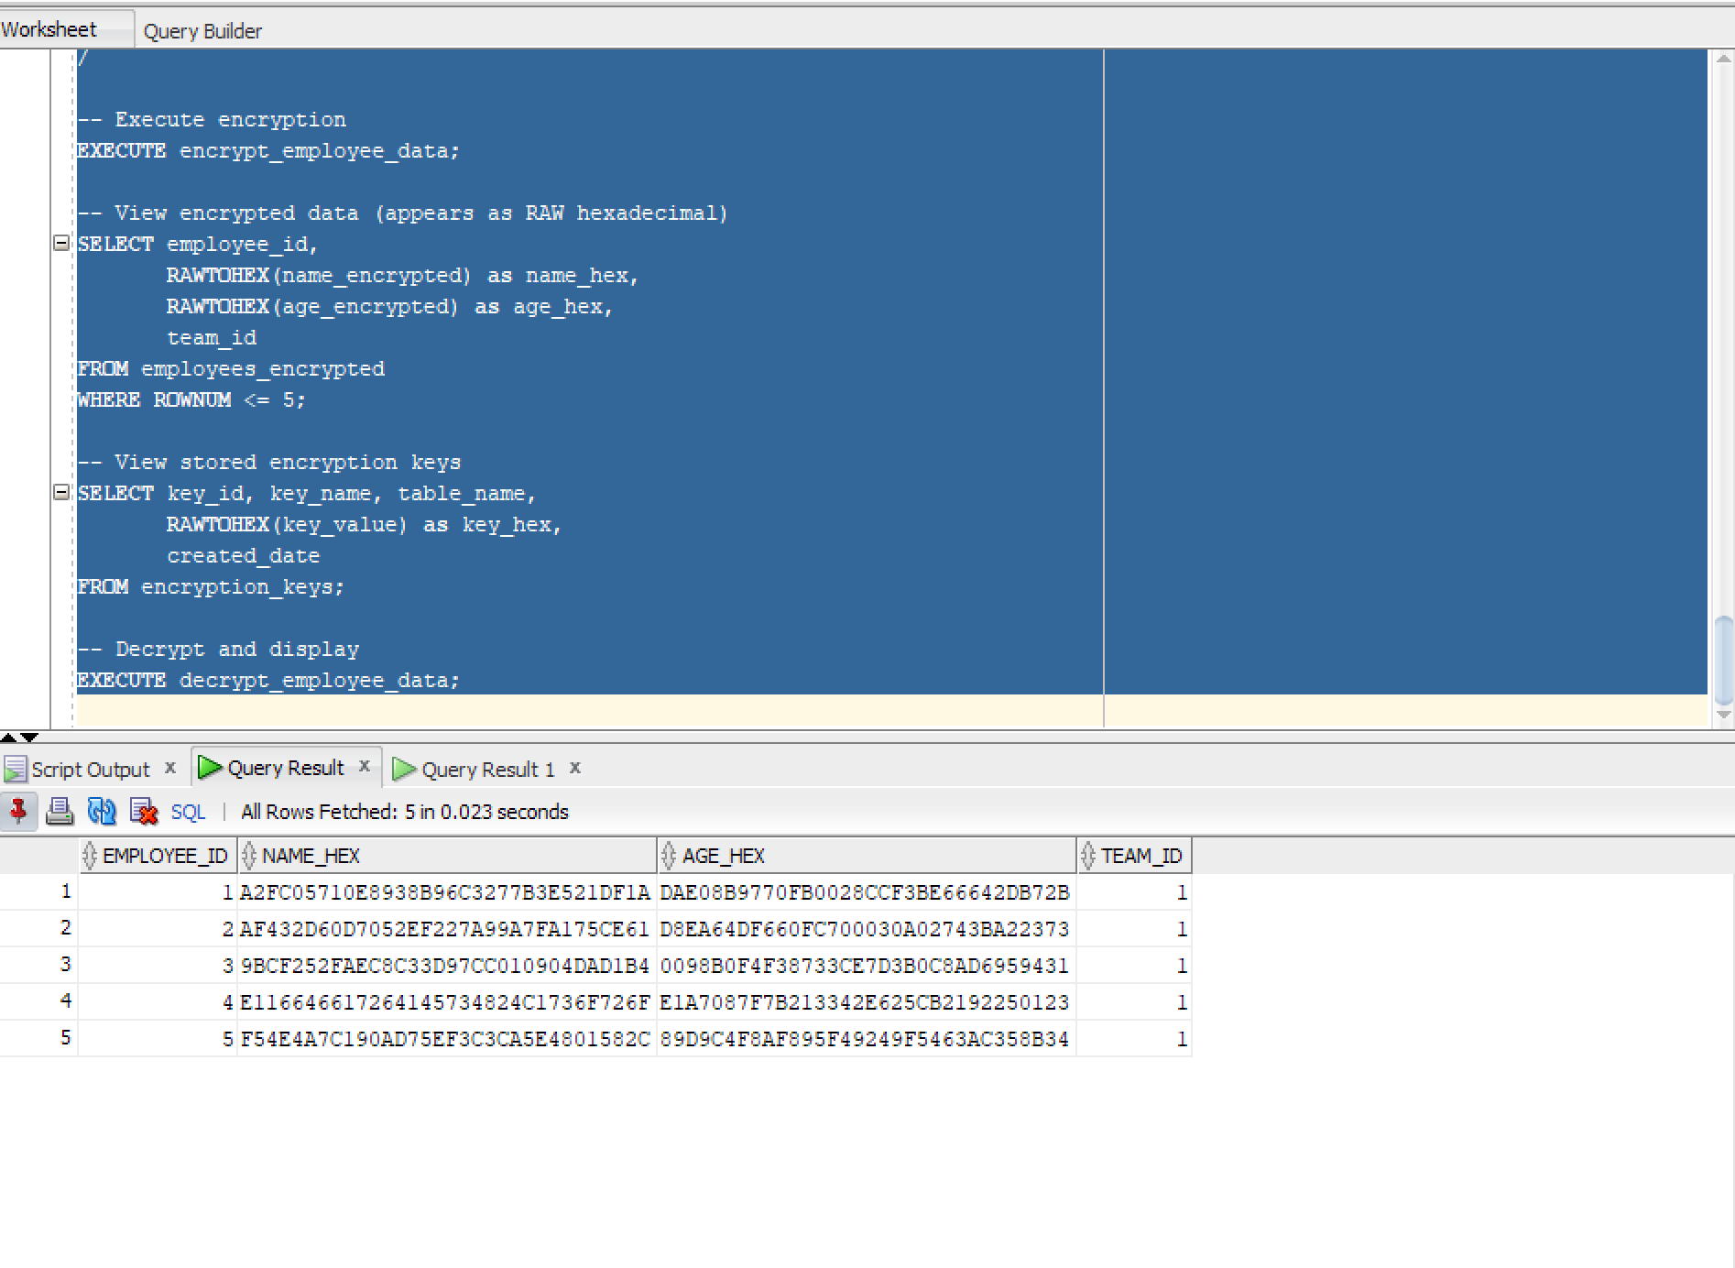
  - Automated Encryption with Key Management
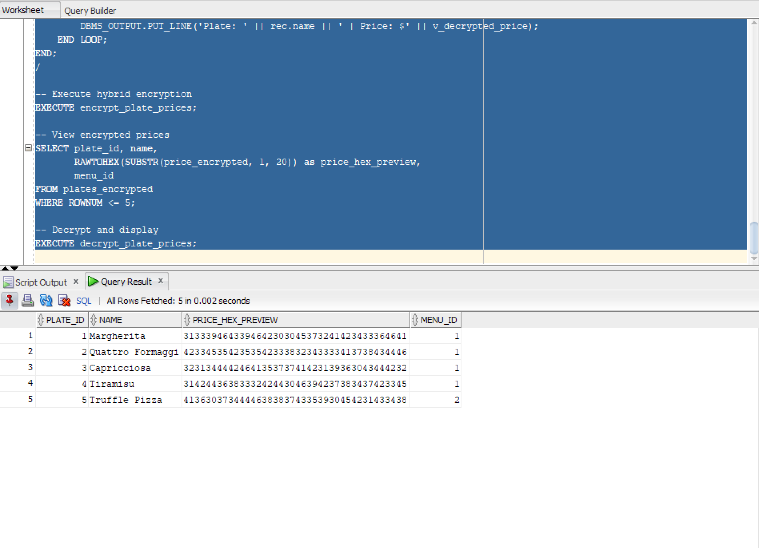
  - Hybrid Key Encryption (Master Key + Row Key)
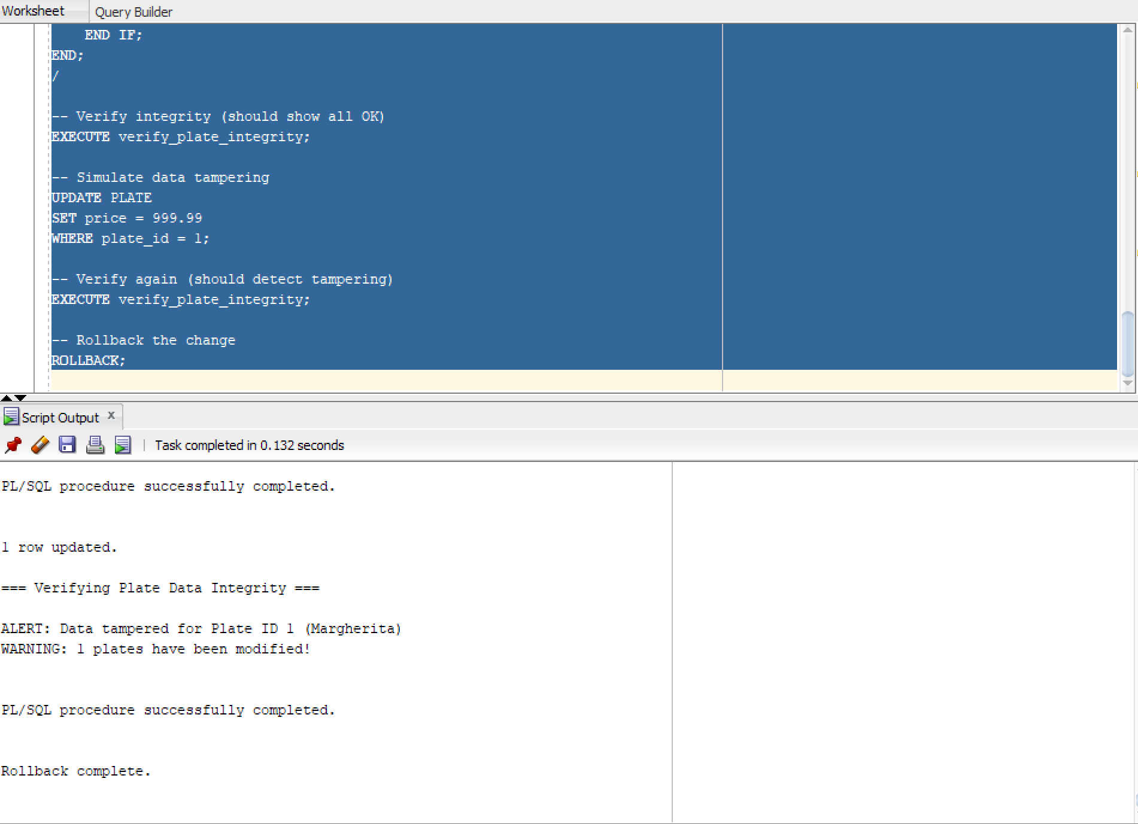
  - Data Integrity with Hashing
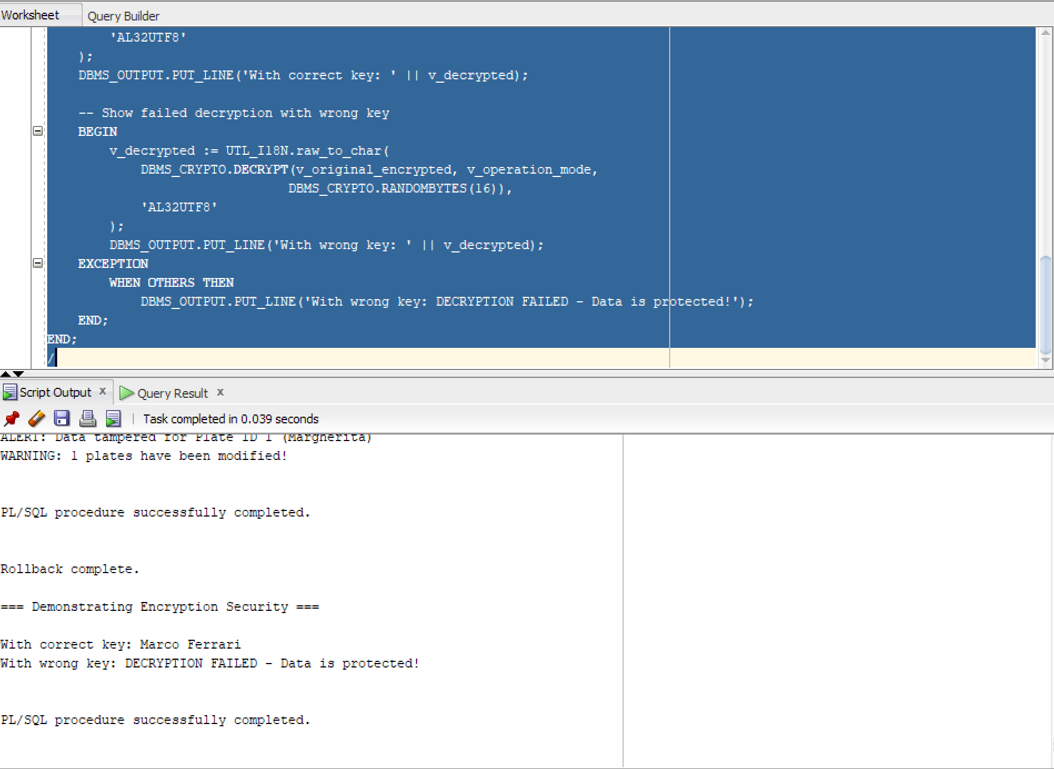
  - Demonstration of Security Benefits
- Database activity Auditing
  - Standard Auditing
  - Audit Triggers
  - Audit Policies

